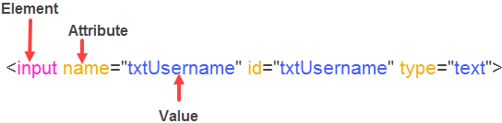

1. Locating elements **when one attribute value is unique**.

Syntax: //*[@attributeName=’value’]

http://pragmatictestlabs.com/wp-content/uploads/2016/09/4.png

Example:

//*[@id=’txtUsername’]

//*[@name=’tstUsername’]

2. Locating elements with **known element** and **attributes**

Syntax: //elementName[@attributeName=’value’]

Example:

//input[@id=’txtUsername’]

//input[@name=’tstUsername’]

3. Locating elements with known **visible Text** (exact match)

Syntax: //elementName[text()=’exact text’] or

/*[text()=’exact text’]

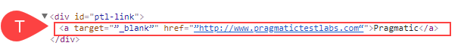

Examples:

//a[text()=’Pragmatic’]

//*[text()=’Pragmatic’]

4. Locating elements when the **partial visible text** is known (partial match)

Syntax: //elementName[contains(text(),’part of text’] or

//elementName[contains.,’part of text’] or

//*[contains(text(),’part of text’]

http://pragmatictestlabs.com/wp-content/uploads/2016/09/7-1.png

Examples:

//a[contains(text(),’Pragmatic’]

//a[contains(.,’Pragmatic’]

//*[contains(text(),’Test Labs’)]

5. Locating elements with **Multiple attributes**

Syntax: //elementName[attribute1=’value’][attribute2=’value’] or //*[attribute1=’value1’][attribute2=’value2’][attribute3=’value3’]

http://pragmatictestlabs.com/wp-content/uploads/2016/09/8-1.png

Examples:

//input[@class=’button’][@name=’Submit’][@value=’LOGIN’]

//*[@id=’btnLogin’][@class=’button’]

6. Locating elements when **starting visible text** known

Syntax: //elementName[starts-with(text(),’starting text’)] or

//*[starts-with(text(),’starting text’)]

http://pragmatictestlabs.com/wp-content/uploads/2016/09/9.png

Examples:

//a[starts-with(text(),’Pragmatic’)]

//*[starts-with(text(),’Pragmatic’)]

7. Locating elements with **Dynamic Attribute values**

Syntax: //elementName[contains(@attributeName,’part of the value’)] or

//*[ contains(@attributeName,’part of the value’)]

// elementName[start-with(@attributeName,’fixed prefix of the value’)]

http://pragmatictestlabs.com/wp-content/uploads/2016/09/9.png

Examples:

//a[contains(@href,’pragmatic’)]

//*[contains(@href,’testlabs’)]

//*[starts-with(@href,’pragmatic’)]

8. Locating a **parent element** (parent axis contains the parent of the context node)

Syntax: //<knownXPath>/parent:: elementName or

//<knownXPath>/parent::*

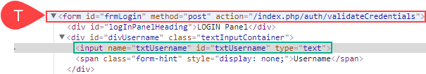

Examples:

//div[@id=’divUsername’]/parent::form

//div[@id=’divUsername’]/parent::*

//div[@id=’divUsername’]/..

9. Locating a **child element** (parent axis contains the parent of the context node)

Syntax: //<XPathOfknownElement>/child:: elementName or

//<XPathOfknownElement>/child::* or

//<XPathOfknownElement>/ elementName

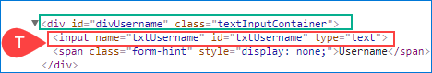

Examples:

//div[@id=’divUsername’]/child::input

//div[@id=’divUsername’]/input

XPath: is for locating the elements or nodes in XML documents. XML and HTML has similar syntax

(HTML is a subset of XML) hence XPath can be used locate elements in HTML.